Sales data analysis report

For an Electronics Store

Bushra Ghaffar

bushraghaffar33@gmail.com

Sales Data Analysis Report

1. Data Collection:

The Sales Dataset is a comprehensive collection of data pertaining to sales transactions for a specific company or business. This dataset provides valuable insights into the company's sales performance, including details about the quantity of products ordered, customer addresses, order locations, specific products sold, and timestamps for order dates and times. It serves as a crucial resource for businesses to analyze and optimize their sales operations, make informed decisions, and enhance customer satisfaction.

Dataset Link : [Sales dataset](https://drive.google.com/drive/folders/15yHQJOO8gm8vb_TAlhvLeo__RTQ1T8ux)

1. Data Cleaning:

In the data cleaning process for the Sales Dataset, it's crucial to eliminate duplicate rows, correct spelling errors, address empty rows, ensure proper formatting of the "Order Date" column for consistent date representation, and verify that the "Sales" column follows a uniform monetary format. These steps are essential to maintain data accuracy, integrity, and readiness for analysis, enabling businesses to derive reliable insights and make informed decisions based on clean and consistent data.

1. Analyzing the Data: (using Excel)

The Sales Dynamic Dashboard in Excel is a powerful tool designed to provide real-time insights and visualizations of sales data for a business or company. This interactive dashboard offers a user-friendly interface with multiple charts and features that allow users to analyze and track various aspects of sales performance at a glance.

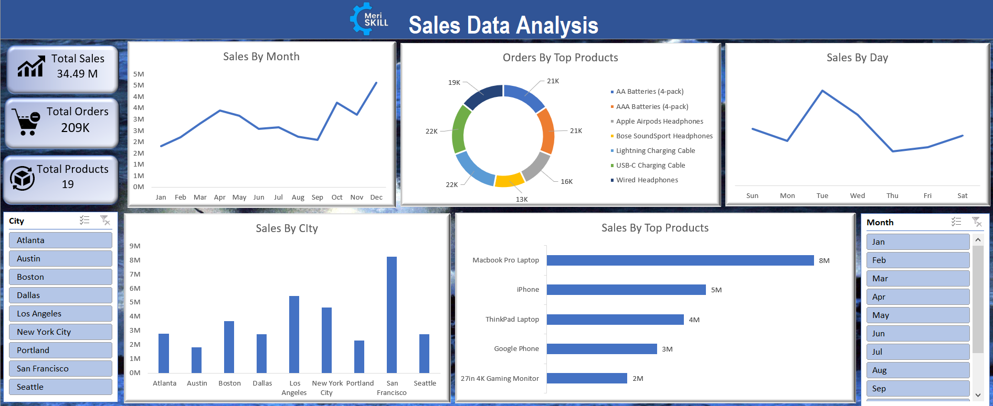

*Fig 1: Sales Data Analysis Dashboard*

**Key Features of the Dashboard:**

1. **Total Sales Overview:** At the top of the dashboard, you'll find the total sales, giving an instant snapshot of the revenue generated over a selected period.

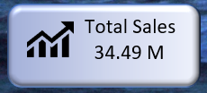

*Fig 2: Total Sales*

1. **Total Quantity Ordered:** This section illustrates the total quantity of products ordered. It allows users to assess the overall demand for products and spot trends in ordering patterns.

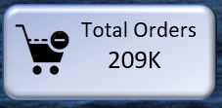

*Fig 3: Total Orders*

1. **Sales by Month:** A monthly sales chart provides a clear visualization of sales performance over time. Users can easily identify seasonal trends, track growth, and evaluate the impact of marketing campaigns or promotions.

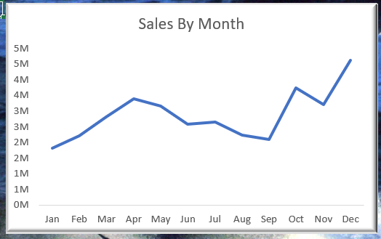

*Fig 4: Sales by Month*

1. **Sales by Day:** The daily sales chart offers a detailed breakdown of sales on a daily basis. This information is invaluable for identifying sales spikes, tracking daily fluctuations, and optimizing operational resources.

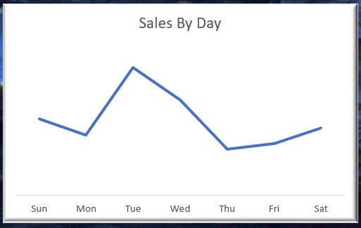

*Fig 5: Sales by Day*

1. **Top Selling Products:** Users can quickly identify the top-selling products with an interactive chart that lists the products generating the highest revenue. This insight helps businesses focus on promoting and managing their best-performing products.

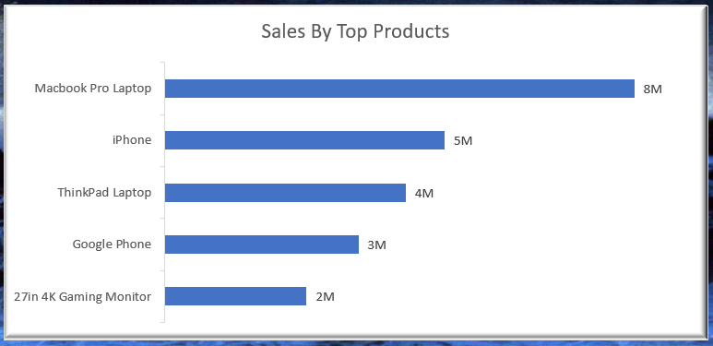

*Fig 6: Sales by Top Products*

1. **Top Ordered Products:** Similar to the top-selling products chart, this section highlights the products with the highest order quantities. This data is crucial for inventory management and restocking decisions.

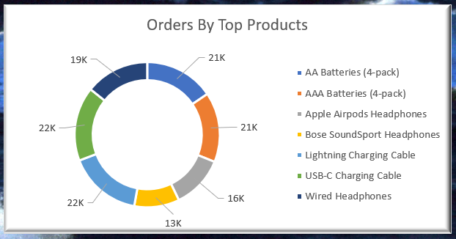

*Fig 7: Orders by Top Products*

1. **Sales by City:** A geographic chart displays sales data by city, allowing users to identify regions with the highest and lowest sales volumes. This information is essential for targeted marketing and regional sales strategies.

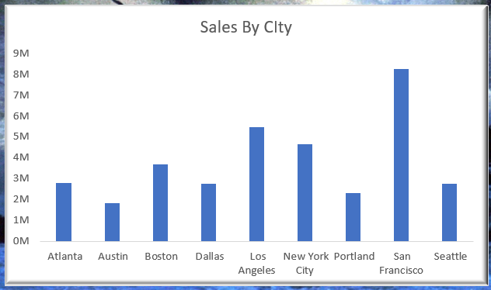

*Fig 8: Sales by City*

**Interactivity and User Customization:**

* Users can select specific time cities, or product categories to filter and view relevant data.
* Interactive elements, such as drop-down menus or slicers, enable users to customize the dashboard to their preferences.

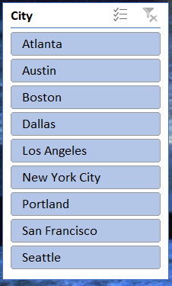 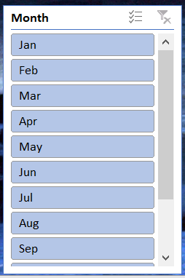

*Fig 9: City & Month Slicers*

1. Results:

Key Findings from Sales Data Analysis:

1. **Peak Selling Months:** April, October, and December emerge as the peak months for product sales, indicating higher demand during these periods, possibly due to seasonal factors or holidays.
2. **Top Sales City:** San Francisco stands out as the city with the highest sales, suggesting a significant customer base and strong market presence in this region.
3. **Day of Peak Sales:** Tuesdays consistently record the highest sales, implying that customers tend to make more purchases early in the week.
4. **Most Ordered Products:** The USB-C charging cable and Lightning charging cable are the most frequently ordered products, indicating their popularity among customers, likely due to their utility and compatibility with various devices.
5. **Top Selling Products:** The top-performing products in terms of sales revenue are the MacBook Pro Laptop, iPhone, and ThinkPad Laptop, underlining their desirability and strong market demand

These key findings provide valuable insights into sales trends and customer preferences, which can inform strategic decision-making for inventory management, marketing campaigns, and sales strategies.